**CHAPTER 1**

**INTRODUCTION**

One of the greatest challenges for educational planners and administrators has been to equalize educational opportunities for all, to provide easy access to educational facilities to all children. If all habitation / villages are to be provided with a school than the question of equality does not arise. But in real life situations we locate schools in such villages so that other habitations and villages also benefit. How do we decide on the village/ habitations where schools are to be opened so as to ensure equality of educational opportunities? The answer of this question /issue is found at the center of any discussion of SM, GIS and/or PPGIS that attempts an honest inclusion of decentralized participants at any scale.

**1.1 OVERVIEW**

Access to education can be of three kinds. Firstly, physical access, which emphasizes that geographical distance between schools and households, is to be minimized. Secondly, economic access, which implies the financial capacity of households to send children to schools even when facilities are easily accessible in a geographical sense. Thirdly, social access which means that social stratification based on caste, class and religion has implications for access available public provisions. In countries like India various social factors come in the way of sending children to school. While the potential demand for education depends on physical access, the realized/effective household demand depends on economic and social access. In other words, existence of schooling facilities in any particular geographical area does not necessarily lead to an increase in household demand for schooling. The relative economic and social status to a large extent determines the realized household demand for education.

**1.2 LITERATURE SURVEY**

The term school mapping seemingly implies that the exercise is confined to location of schools. This is not true. School mapping is an exercise useful to rationally allocate educational facilities of any type related to any level of education. According to available accounts, school mapping originated in France in 1963 (Caillods, 1983; Da Graça, 1998; Galabawa, Agu, & Miyazawa, 2002; Govinda, 1999). School mapping (SM) is a normative approach to the micro‐planning of school locations. It is an essential planning tool to overcome possibilities of regional inequalities in the provision of educational facilities. It means that 1. SM incorporates spatial and demographic dimensions into the educational planning process. 2. Location of educational facilities depends on the norms and standards prescribed by the authorities.

**1.3 OBJECTIVES**

* The objective of the project is,
* To create website for GPS- mapping
* To create a login page.
* To display the current live news updates.
* To provide the exact location of schools with necessary details.

**CHAPTER -2**

**SYSTEM ANALYSIS**

* 1. **EXISTING SYSTEM**

Nagaland CM launches GPS mapping of schools Kohima, Nov 07 (UNI) Nagaland Chief Minister Nephi Rio has launched GPS Mapping of all Government Schools and the Personnel Location System (PLS) yesterday, a significant step towards computerization and digitization of records by the School Education department. According to an official report, speaking at the launching programme, the Chief Minister congratulated the Department for the exercise undertaken. Rio was of the view that the department should keep visitors' book in all schools so that visiting or inspecting officials and also dignitaries place their visits or inspection reports on record. He suggested that the records could be digitized to be viewed by MLAs concerned and be aware of the status of schools within their respective constituencies. Presently, the GPS & PLS information, which can be accessed online through http://.[**dose-ngl.com**](http://dose-ngl.com/) has the GPS coordinates of all the schools pinned and marked on Google Maps, with other information like enrolment, facilities such as number of classrooms, power and water connection availability, playground .

* + 1. **Drawbacks**

The drawbacks of the system are:

1. No provide Security Features.
2. Inefficient informations.
3. No news feed.

**2.2 PROBLEM DEFINITION**

Nowadays, there were no websites for Government schools in tamilnadu so we fond of creating a website for that purpose, the website services have a deep inﬂuence on information spreading processes.

The easy access of website services not only promotes the efficiency of information but also provides day to activity that was happening in and around the state.

* 1. **PROPOSED SYSTEM**
* We add the news feed in the page update the page with neat UI(user interface)login page and so on and with the loacation.
* We also Post the Calendar inorder to know about the Academic details and Academic Events.
* It has facilities to generate the report inorder to operate the Education System Effectively.
* It is envisaged that this information on public domain, which may perhaps be a first in the state, would facilitate in departmental information being made more accessible to the public. .
* We will also display the Schemes established by the Government inorder to know the Available Scholarships for the Poor Children’s to get a Valuable Education.

**2.3.1 Advantages**

* Provides geo-location information.
* News feeds.
* Easier access.
* User friendly.

**CHAPTER 3**

**SOFTWARE REQUIREMENT**

**3.1 INTRODUCTION**

The following describes the requirement specification for GPS mapping of schools in Tamilnadu.

**3.1.1 Purpose**

The purpose of this document is to provide Software Requirement Specifications for “GPS-Mapping of schools in Tamilnadu”. Thereby the technique of detecting the exact locations and information’s about Government schools is explained through this report.

**3.3 PLATFORM DESCRIPTION**

Though there are numerous operating systems found in the field of Information Technology, this project work is carried out in Any operating system with a browser.

* 1. **SOFTWARE DESCRIPTION**

In order to simulate the project, various programming lanuages has been used and it is simulated using the Browser Network to illustrate the technique used in this project.

* 1. **OPERATIONAL REQUIREMENTS**

**3.5.1 Performance Requirements**

1. Fast connection
2. less storage
3. output devices
4. Low power consumption

**3.5.2 Non Functional Requirements**

The system also provides these following non-functional requirements:

1. Reliability: The degree of measurement and calculation of the system can be depended on to be accurate.
2. Scalability: The system has the capacity to perform even when the number of nodes involved in the network may vary in scale.
3. Maintainability: It is easy to isolate the defects or their cause, correct defects or their cause, repair or replace the fault.
4. Portability: The website can be easily seen in any system.
5. Security: The system has a quality of being trustworthy or of performing consistently well.

**3.6 HARDWARE REQUIREMENTS**

**3.6.1 Minimum Requirements**

1. Processor : Intel Pentium 4
2. Hard Disk Space : 128 GB
3. Monitor : 14’’
4. Keyboard : 102 KEYS
5. Internal Memory Capacity : 256 MB
6. Internet connection :512kbps

**3.6.2 Maximum Requirements**

1. Processor : Intel Core i3
2. Hard Disk Space : 250GB
3. Monitor : 15.6’’
4. Keyboard : 104 KEYS
5. Internal Memory Capacity : 2 GB
6. Internet connection : 1mbps

**3.7 SOFTWARE REQUIREMENTS**

1. Operating System : linux/windows/mac
2. Coding Language : PhP,html,css
3. Tool Used :Internet Browser

**3.8 FEASIBILITY STUDY**

This section provides the overview of the economic, operational and technical feasibility of the project for real time implementation.

**3.8.1 Economic Feasibility**

The main part of expenditures of the project is software costs. This includes the initial investment for mapping Google-maps software in the platform of Windows operating system.

**CHAPTER 4**

**SYSTEM DESIGN**

**4.1 SYSTEM ARCHITECTURE**

The project has come up with the following proposed architecture for the implementation of “GPS-MAPPING OF SCHOOLS IN TAMILNADU”.

**4.2 CONTEXT DIAGRAM**

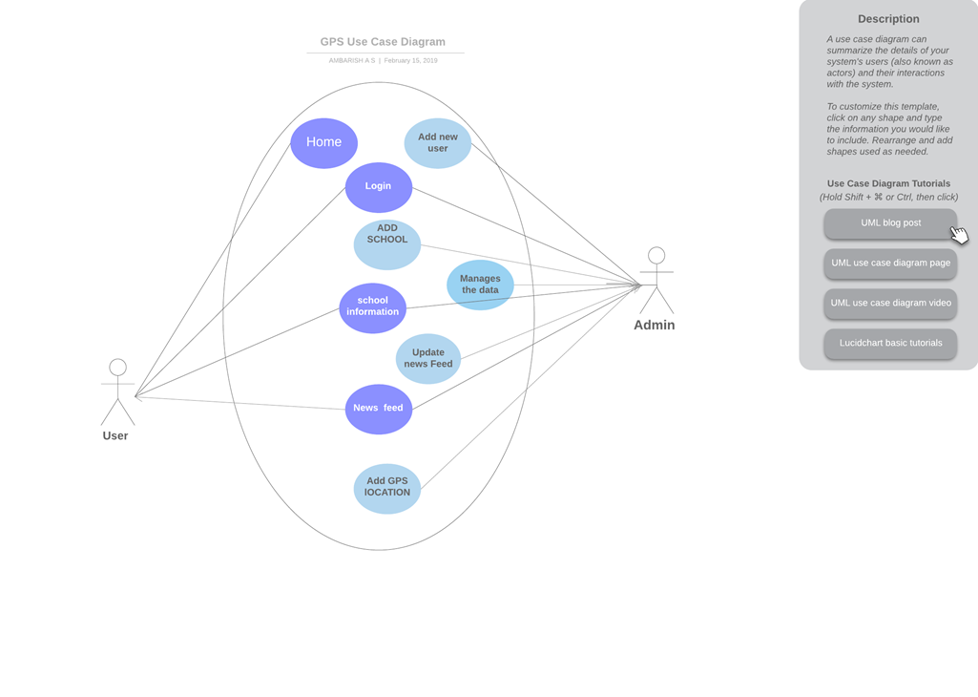

**Fig 4.2 Context diagram**

* + 1. **Determining the real source**

The set of suspects is further narrowed down to the real source. The ML-based method exposes the real source from set of suspects that provides the largest maximum likelihood to match the observation. It is expected that the real source will produce a propagation which not only temporally but also spatially matches the observation more than other suspects.

**CHAPTER 5**

**WEBSITE DESCRIPTION**

**5.1 MICRO PLANNING:**

School mapping and micro planning are complimentary exercise but they are not the same. Objective of Micro Planning is (i)To mobilize the local community to prepare village level plan.(ii)To provide support system to the school become functional.(iii)To ensure that all eligible children from the locality attached the schools and thereby to ensure better and efficient utilization of resources already provided to a particular locality area or school.

**5.1.1 Network Simulator**

A network simulator is a software program that imitates the working of a computer network. In simulators, the computer network is typically modeled with devices, traffic etc. and the performance is analyzed. Typically, users can then customize the simulator to fulfill their specific analysis needs. Simulators typically come with support for the most popular protocols in use today.

**5.1.2 KEY TECHNOLOGYS:**

* HTML
* CSS
* PHP
* SQL

* **HTML**

HTML is a hypertext markup language which is in reality a backbone of any website. Every website can’t be structured without the knowledge of html. If we make our web page only with the help of html, than we can’t add many of the effective features in a web page, for making a web page more effective we use various platforms such as CSS.

* **Cascading Style Sheets (CSS)**

It is a style sheet language used for describing the presentation of a document written in a markup language like HTML.CSS is a cornerstone technology of the World Wide Web, alongside HTML and JavaScript.

* **JavaScript (JS)**

It is a lightweight, interpreted or JIT compiled programming language with first-class functions. Most well-known as the scripting language for Web pages, many non-browser environments also use it, such as node.js and Apache CouchDB.

* **Structured Query Language or SQL**

It is a standard Database language which is used to create, maintain and retrieve the relational database. It is particularly used to work with structured data where there is relations associated within the data itself.

**5.1.3.1 Advantages**

* Flexible and state of the art tool
* contains wide classes of internet protocols including
* Multicasting, and wireless networks
* Widely used for results and easy to access.

**5.1.3.2 Disadvantages**

* Minimal docs
* Incomplete API

**CHAPTER 6**

**SYSTEM IMPLEMENTATION AND RESULT**

**6.1 SYSTEM IMPLEMENTATION**

Our current system is implemented with the help of network Browser using the following steps:

**Specification of norms standards & catchment area**

• Norms for opening of new schools.

• Distance/Population/Difficult area

• Norms for teacher.

**Diagnosis of exiting educational facilities.**

Assessment of existing educational facilities in selected area or region schools

Required information is useful to prepare school specific plan.

1. Literacy Rate/ Enrolment Rate /Retention Rate/ Dropout Rate etc.
2. No of Teachers.
3. Teacher pupil ratio

(iv) Building and infrastructure facilities

1. Blackboard, water, Toilet, electricity playground etc.

**Projection of future child population.**

• Assessment the number of children which is to be enrolled.

• It is based on projection of child population in the catchment area.

**Benefits**

Assessing the requirements or facilities in schools :-

• Assessment of requirement of facilities in new school and in existing schools.

• This includes requirement of infrastructure facilities and teaching learning materials.

Estimating financial resources requirement.

• Based on the requirement of facilities cost estimates can be made and proposal can be made for funding.

Prioritization of assessed requirement & facilities in the schools according to financial resources.

• Based on the available budget for every year proposal can be made.

**6.2 RESULT**

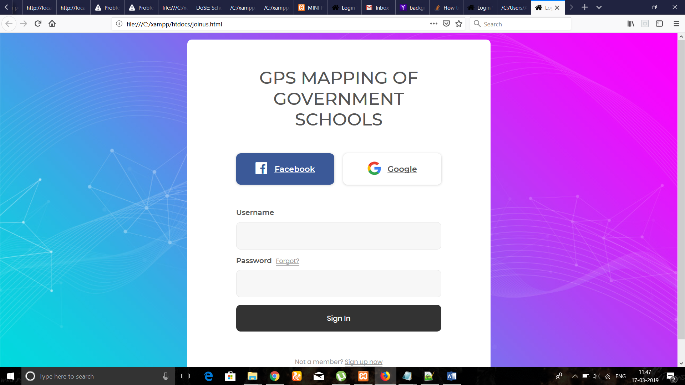

**Fig 6.1: Login page**

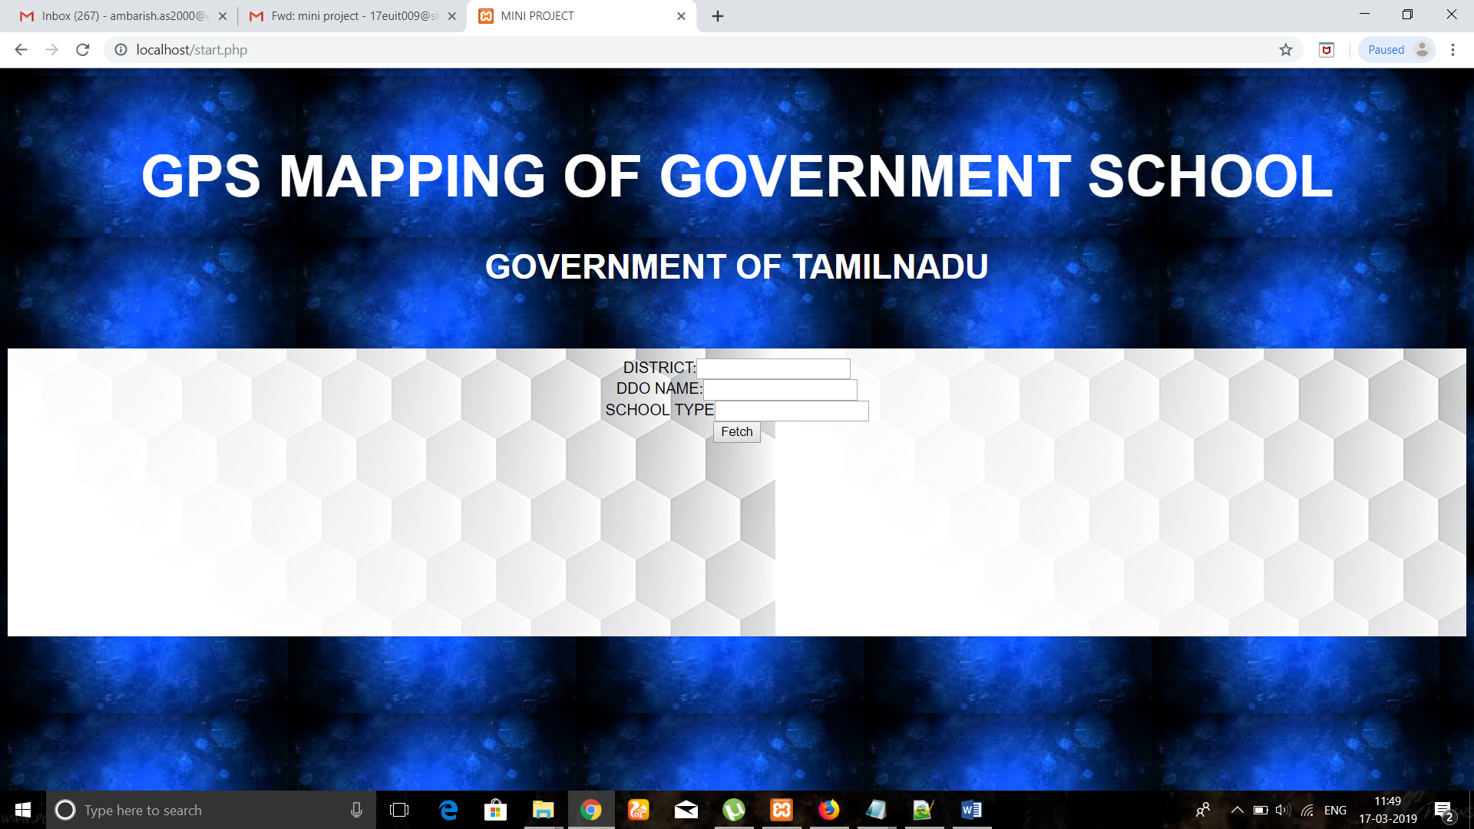

**Fig 6.2: Homepage of our Website**

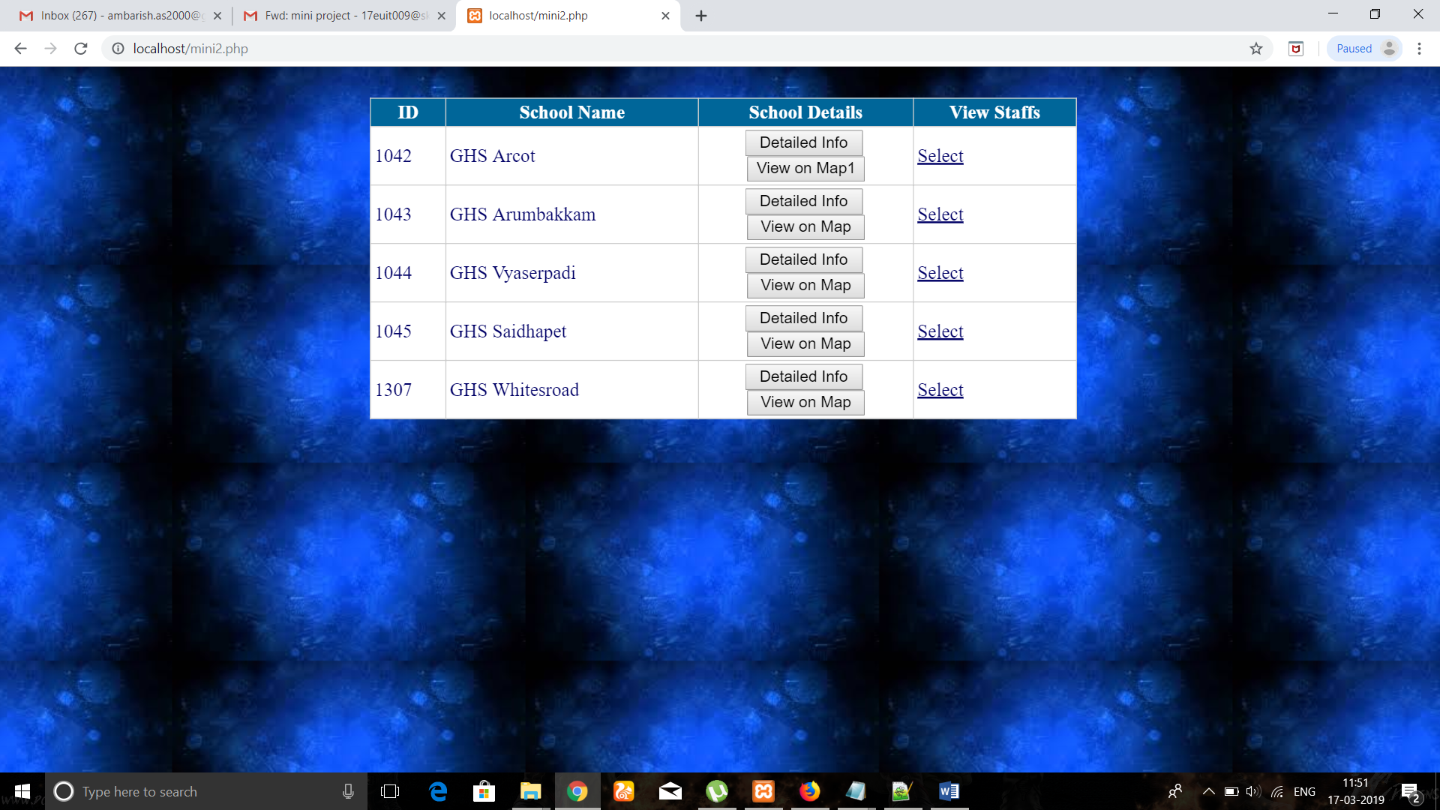

**Fig 6.3: Schools located in particular city**

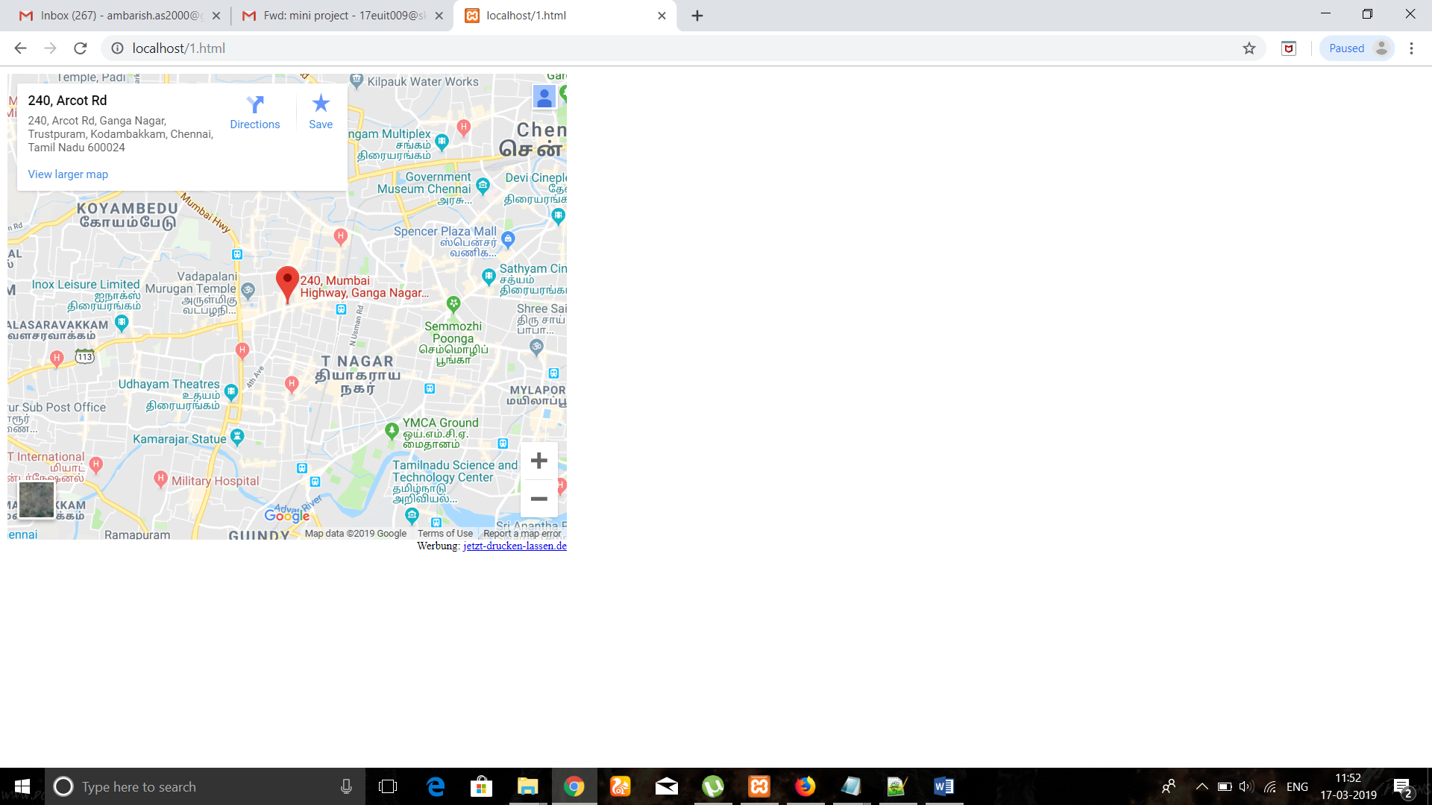

**Fig 6.4: GPS Location of school.**

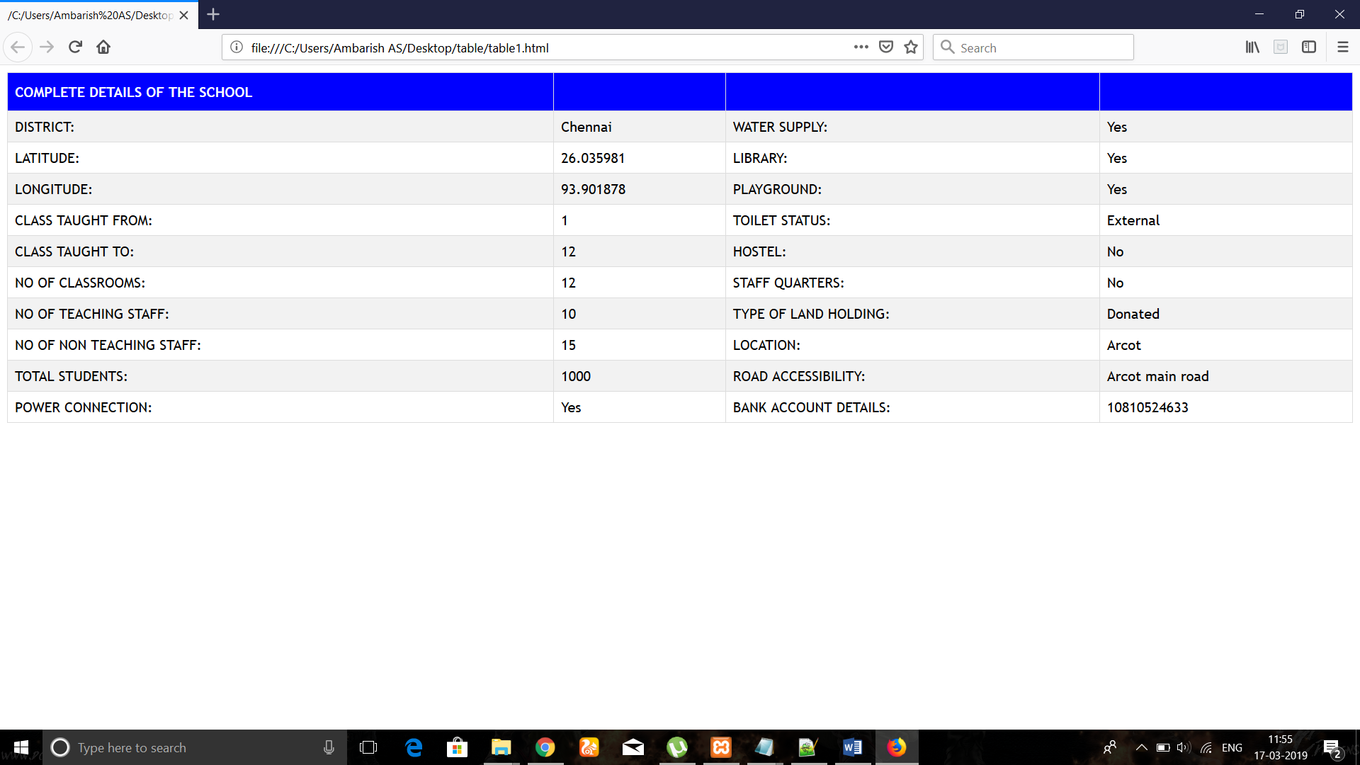

Fig 6.5: Complete details of the school.

SOURCE CODE:

For Introduction Page:

**<?php**

**if(isset($_POST['Fetch'])){**

**$dist = $_POST['district'];**

**if($dist == 'chennai'){**

**header('location: mini2.php');**

**}**

**if(isset($_POST[‘Fetch’])){**

**$dist=$_POST[‘district’];**

**if($dist==’coimbatore’){**

**header(‘location:mini2.php’);**

**}**

**if(isset($_POST[‘Fetch’])){**

**$dist=$_POST[‘district’];**

**if($dist==’salem’){**

**header(‘location:mini3.php’);**

**}**

**if(isset($_POST[‘Fetch’])){**

**$dist=$_POST[‘district’];**

**if($dist==’madurai’){**

**header(‘location:mini4.php’);**

**}**

**}**

**?>**

**<html>**

**<head>**

**<title>MINI PROJECT</title>**

**<link href="front.css" rel="stylesheet" type="text/css" />**

**</head>**

**<body>**

**<div class="header">**

**<h1>GPS MAPPING OF GOVERNMENT SCHOOL</h1>**

**<h3>GOVERNMENT OF TAMILNADU</h3>**

**</div>**

**<div class="row">**

**<div class="column middle" align="center" style="background-color:#bbb;">**

**<form action="<?php echo htmlspecialchars($_SERVER['PHP_SELF']); ?>" method="POST">**

**DISTRICT:<input type="text" name="district"><br>**

**DDO NAME:<input type="text" name="ddo"><br>**

**SCHOOL TYPE<input type="text" name="school"<br>**

**<div align="center">**

**<input type="submit" value="Fetch" name='Fetch'/>**

**</form>**

**</div>**

**</div>**

**</div>**

**</body>**

**</html>**

**CSS for Introduction Page:**

**\* {**

**box-sizing: border-box;**

**}**

**body {**

**font-family: Arial, Helvetica, sans-serif;**

**background-image:url("amb.jpg");**

**}**

**/* Style the header */**

**.header {**

**background-image:url("amb.jpg");**

**padding: 30px;**

**text-align: center;**

**font-size: 30px;**

**color:white;**

**}**

**/* Left and right column */**

**.column.side {**

**width: 25%;**

**}**

**/* Middle column */**

**.column.middle {**

**width: 100%;**

**background-image:url("amba.jpg");**

**}**

**/* Clear floats after the columns */**

**.row:after {**

**content: "";**

**display: table;**

**clear: both;**

**}**

**/* Style the footer */**

**.footer {**

**background-color: #f1f1f1;**

**padding: 10px;**

**text-align: center;**

**}**

**}**

**}**

**Code for Listing Cities:**

**<html> <style> body { background-image:url("amb.jpg"); } </style> <body> { <div align="center"> <table cellspacing="0" cellpadding="3" rules="all" id="MainContent_StaffsGridView" style="background-color:White;border-color:#CCCCCC;border-width:1px;border-style:None;width:600px;border-collapse:collapse;"> <tr style="color:White;background-color:#006699;font-weight:bold;"> <th class="hiddencol" scope="col">ID</th><th scope="col">School Name</th><th scope="col">School Details</th><th scope="col">View Staffs</th> </tr><tr style="color:#000066;"> <td class="hiddencol">1042</td><td>GHS Arcot</td><td align="center"> <input type="submit" name="ctl00$MainContent$StaffsGridView$ctl02$DetailsLink" value="Detailed Info" id="MainContent_StaffsGridView_DetailsLink_0" style="width:100px;" /> <br /> <a href='**[**1.html**](http://localhost/1.html)**'><input type="submit" name="ctl00$MainContent$StaffsGridView$ctl02$OnMapView" value="View on Map1" id="MainContent_StaffsGridView_OnMapView_0" style="width:100px;" /></a> </td><td><a href='**[**table.html**](http://localhost/table.html)**' style="color:#000066;">Select</a></td> </tr><tr style="color:#000066;"> <td class="hiddencol">1043</td><td>GHS Arumbakkam</td><td align="center"> <input type="submit" name="ctl00$MainContent$StaffsGridView$ctl03$DetailsLink" value="Detailed Info" id="MainContent_StaffsGridView_DetailsLink_1" style="width:100px;" /> <br /> <a href='**[**6.html**](http://localhost/6.html)**'><input type="submit" name="ctl00$MainContent$StaffsGridView$ctl03$OnMapView" value="View on Map" id="MainContent_StaffsGridView_OnMapView_1" style="width:100px;" /> </td><td><a href="****javascript:__doPostBack(&#39;ctl00$MainContent$StaffsGridView&#39;,&#39;Select$1&#39;)****" style="color:#000066;">Select</a></td> </tr><tr style="color:#000066;"> <td class="hiddencol">1044</td><td>GHS Vyaserpadi </td><td align="center"> <input type="submit" name="ctl00$MainContent$StaffsGridView$ctl04$DetailsLink" value="Detailed Info" id="MainContent_StaffsGridView_DetailsLink_2" style="width:100px;" /> <br /> <a href='**[**3.html**](http://localhost/3.html)**'><input type="submit" name="ctl00$MainContent$StaffsGridView$ctl04$OnMapView" value="View on Map" id="MainContent_StaffsGridView_OnMapView_2" style="width:100px;" /> </td><td><a href="****javascript:__doPostBack(&#39;ctl00$MainContent$StaffsGridView&#39;,&#39;Select$2&#39;)****" style="color:#000066;">Select</a></td> </tr><tr style="color:#000066;"> <td class="hiddencol">1045</td><td>GHS Saidhapet</td><td align="center"> <input type="submit" name="ctl00$MainContent$StaffsGridView$ctl05$DetailsLink" value="Detailed Info" id="MainContent_StaffsGridView_DetailsLink_3" style="width:100px;" /> <br /> <a href='**[**4.html**](http://localhost/4.html)**'><input type="submit" name="ctl00$MainContent$StaffsGridView$ctl05$OnMapView" value="View on Map" id="MainContent_StaffsGridView_OnMapView_3" style="width:100px;" /> </td><td><a href="****javascript:__doPostBack(&#39;ctl00$MainContent$StaffsGridView&#39;,&#39;Select$3&#39;)****" style="color:#000066;">Select</a></td> </tr><tr style="color:#000066;"> <td class="hiddencol">1307</td><td>GHS Whitesroad</td><td align="center"> <input type="submit" name="ctl00$MainContent$StaffsGridView$ctl06$DetailsLink" value="Detailed Info" id="MainContent_StaffsGridView_DetailsLink_4" style="width:100px;" /> <br /> <a href='**[**5.html**](http://localhost/5.html)**'><input type="submit" name="ctl00$MainContent$StaffsGridView$ctl06$OnMapView" value="View on Map" id="MainContent_StaffsGridView_OnMapView_4" style="width:100px;" /> </td><td><a href="****javascript:__doPostBack(&#39;ctl00$MainContent$StaffsGridView&#39;,&#39;Select$4&#39;)****" style="color:#000066;">Select</a></td> </tr><tr style="color:#000066;"> </tr> </table> </div> </div> <br /> <div class="row" align="center"> </div> </div> </div> <br /> </div> <div class="clear"> </div> </div> <div class="footer"> </div> </div> <script type='text/javascript'>new Sys.WebForms.Menu({ element: 'NavigationMenu', disappearAfter: 500, orientation: 'horizontal', tabIndex: 0, disabled: false });</script></form> </body> </html>**

**Code For Details Of The Staff:**

**<!DOCTYPE html>**

**<html>**

**<head>**

**<style>**

**body**

**{**

**background-image:url("amb.jpg");**

**}**

**#customers {**

**font-family: "Trebuchet MS", Arial, Helvetica, sans-serif;**

**border-collapse: collapse;**

**width: 100%;**

**}**

**#customers td, #customers th {**

**border: 1px solid #ddd;**

**padding: 8px;**

**}**

**#customers tr:nth-child(even){background-color: #f2f2f2;}**

**#customers tr:hover {background-color: #ddd;}**

**#customers th {**

**padding-top: 12px;**

**padding-bottom: 12px;**

**text-align: left;**

**background-color: blue;**

**color: white;**

**}**

**</style>**

**</head>**

**<body>**

**<table id="customers">**

**<tr>**

**<th>COMPLETE DETAILS OF THE SCHOOL</th>**

**<th></th>**

**<th></th>**

**<th></th>**

**</tr>**

**<tr>**

**<td>DISTRICT:</td>**

**<td>Chennai</td>**

**<td>WATER SUPPLY:</td>**

**<td>Yes</td>**

**</tr>**

**<tr>**

**<td>LATITUDE:</td>**

**<td>26.035981</td>**

**<td>LIBRARY:</td>**

**<td>Yes</td>**

**</tr>**

**<tr>**

**<td>LONGITUDE:</td>**

**<td>93.901878</td>**

**<td>PLAYGROUND:</td>**

**<td>Yes</td>**

**</tr>**

**<tr>**

**<td>CLASS TAUGHT FROM:</td>**

**<td>1 </td>**

**<td>TOILET STATUS:</td>**

**<td>External</td>**

**</tr>**

**<tr>**

**<td>CLASS TAUGHT TO:</td>**

**<td>12</td>**

**<td>HOSTEL:</td>**

**<td>No</td>**

**</tr>**

**<tr>**

**<td>NO OF CLASSROOMS:</td>**

**<td>12</td>**

**<td>STAFF QUARTERS:</td>**

**<td>No</td>**

**</tr>**

**<tr>**

**<td>NO OF TEACHING STAFF:</td>**

**<td>10</td>**

**<td>TYPE OF LAND HOLDING:</td>**

**<td>Donated</td>**

**</tr>**

**<tr>**

**<td>NO OF NON TEACHING STAFF:</td>**

**<td>15</td>**

**<td>LOCATION:</td>**

**<td>Arcot</td>**

**</tr>**

**<tr>**

**<td>TOTAL STUDENTS:</td>**

**<td>1000</td>**

**<td>ROAD ACCESSIBILITY:</td>**

**<td>Arcot main road</td>**

**</tr>**

**<tr>**

**<td>POWER CONNECTION:</td>**

**<td>Yes</td>**

**<td>BANK ACCOUNT DETAILS:</td>**

**<td>10810524633</td>**

**</tr>**

**</table>**

**</body>**

**</html>**

**CHAPTER 7**

**CONCLUSION AND FUTURE WORK**

**7.1 CONCLUSION**

In this report, the problem for schools location identification in time-varying social is explored. In order to mapping the challenges posted by website, various innovative methods have been used.. This addresses the scalability and efficiency of Map identification. An analytical model for this project can be introduced in social networks to create an awareness. Based on this model, the exact location is calculated for each suspect to determine the real source from the suspects. Then, the News feeds which are avail in our websites is more useful for the teachers to get lively updates abut in and around happenings.

**7.2 FUTURE WORK**

There is some future work which can be done in this report.However, the website involved in the project are viewed and analysed through three types of observations in Internet. Hence, further types of observations can be considered. The work may also involve in identifying the sources of biometrics and with the help of that the datas are further updated in our website for upcoming future needs.

**REFERENCES:**

<http://www.uniindia.com/nagaland-cm-launches-gps-mapping-of-schools/east/news/1399512.html>

<http://35.154.199.165/dosesurvey/default.aspx>

<https://web.stevens.edu/ses/documents/fileadmin/documents/> <https://www.computer.org/csdl/trans/tq/preprint/>